OTHER EVALUATIONS (*):
Members | Task Details
Member 1 | 3 Tasks - 100%

TASK ASSIGNMENT TABLE:
Content | Result
Average total time to complete the lab (1) | 4 hours
Video Link (2)
(if any)
Feedback (3) (if any)
+ Challenges
+ Suggestions …
Self-Assessment Score (4) | 10/10
(*): Sections (1) and (4) are mandatory.

Teacher: Phan Trung Phát

Name | ID
Trần Anh Tuấn | 24521943

Configuring Network Devices
5

Task 1: Configuring Wireless Network Devices
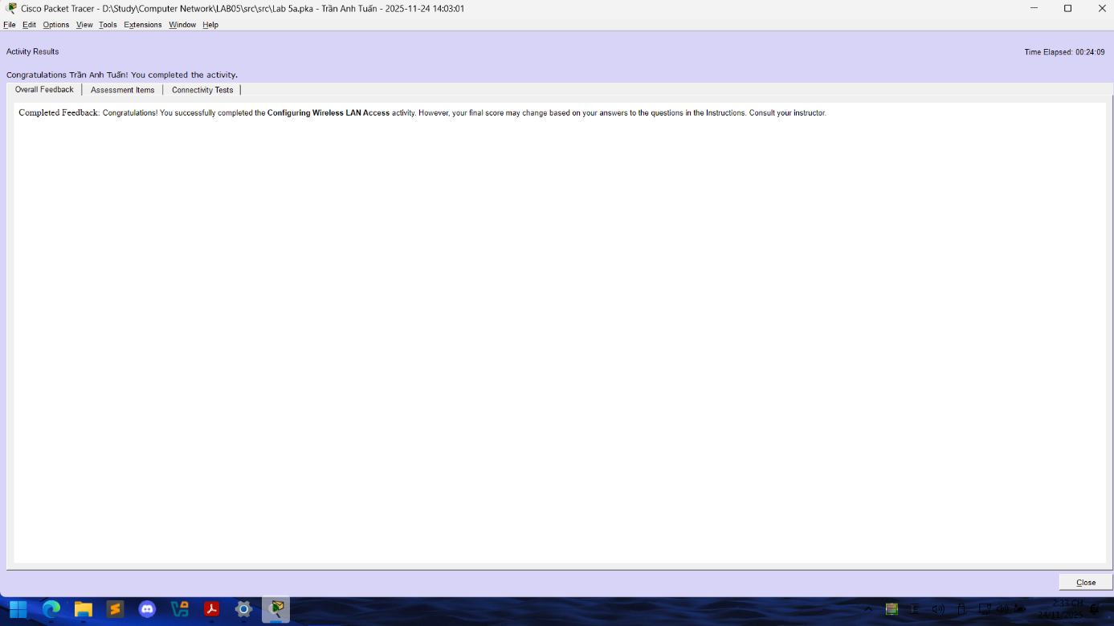

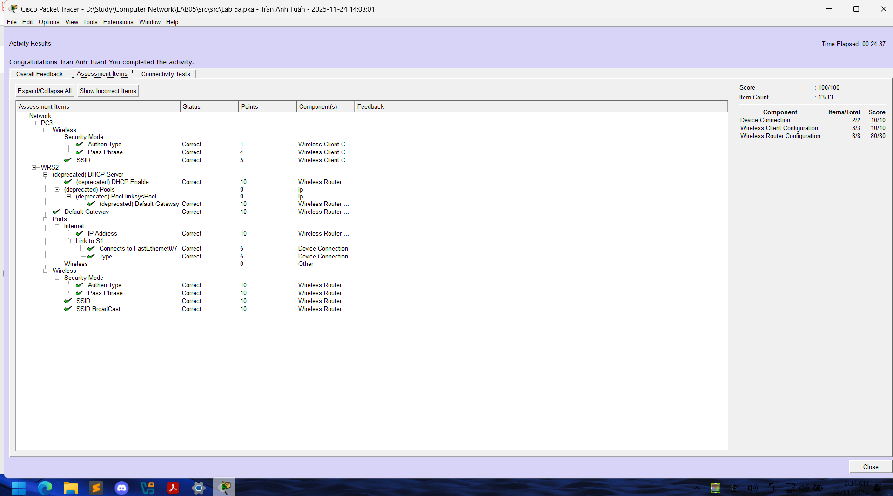

Task 2: Configuring IP Addresses on a Router
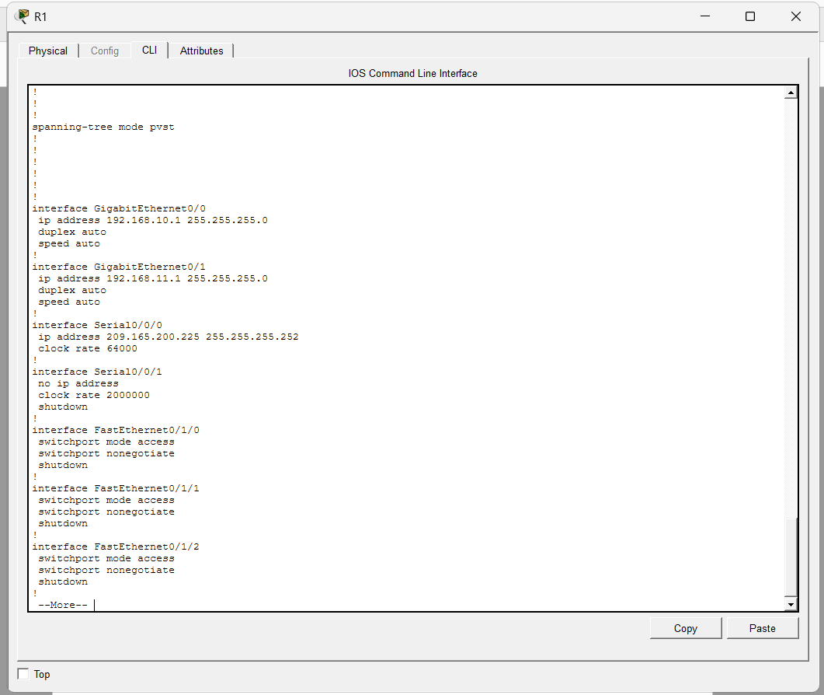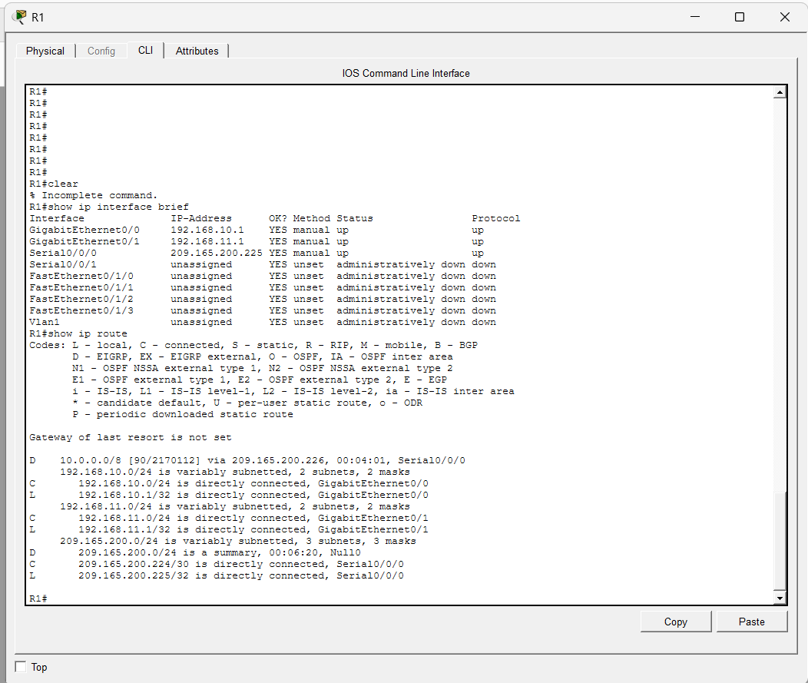

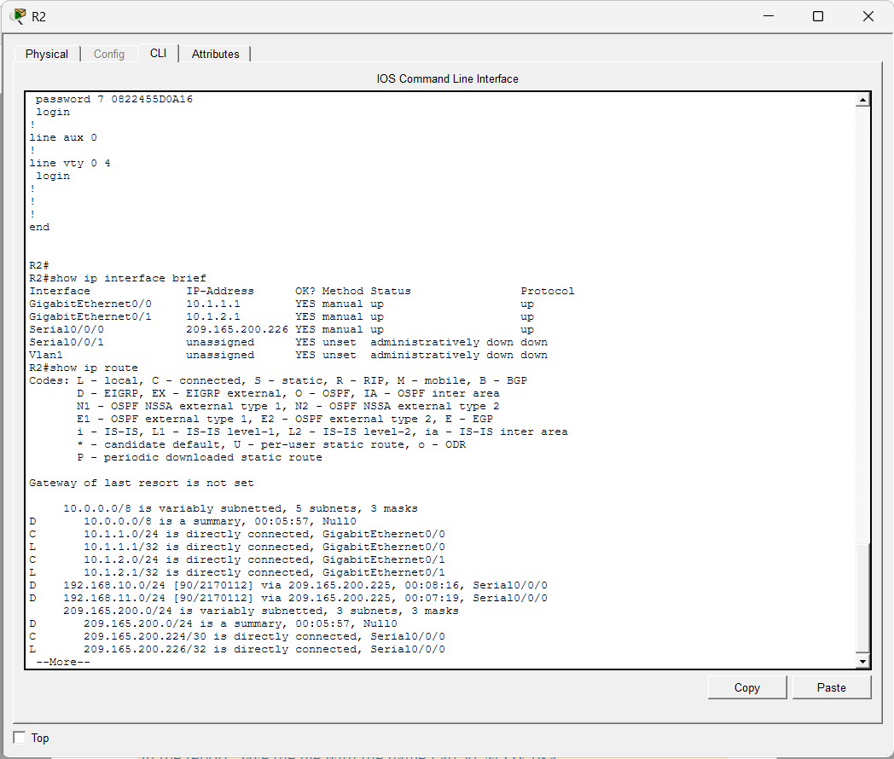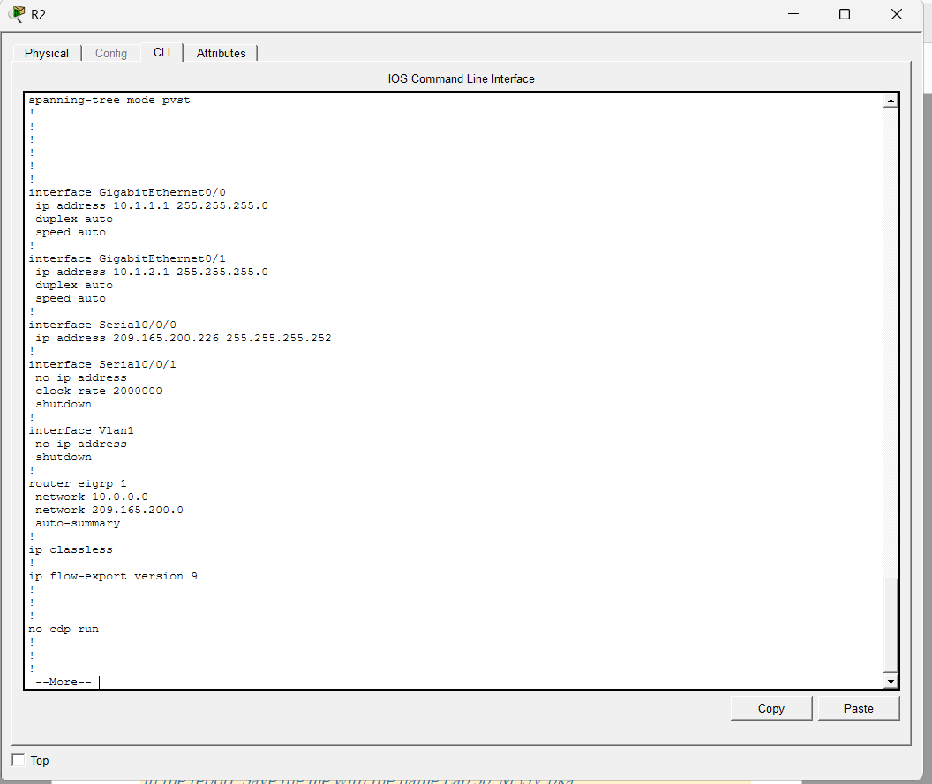

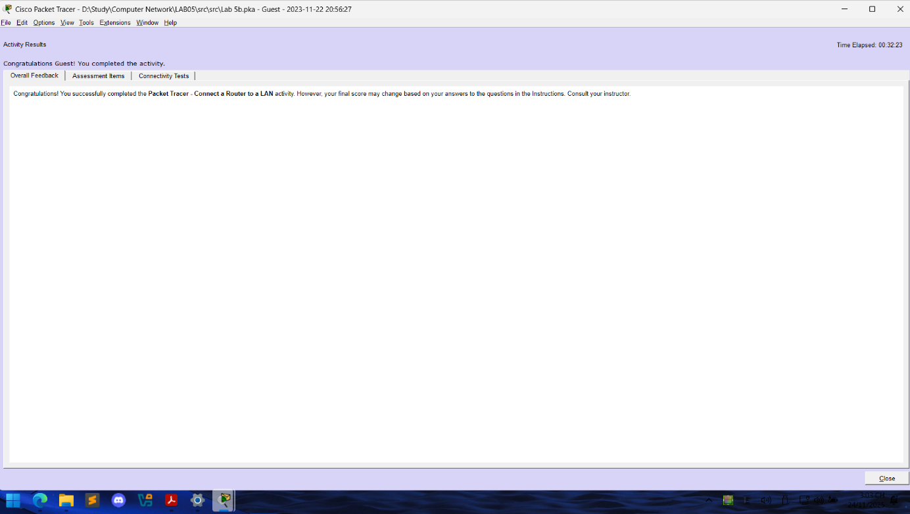
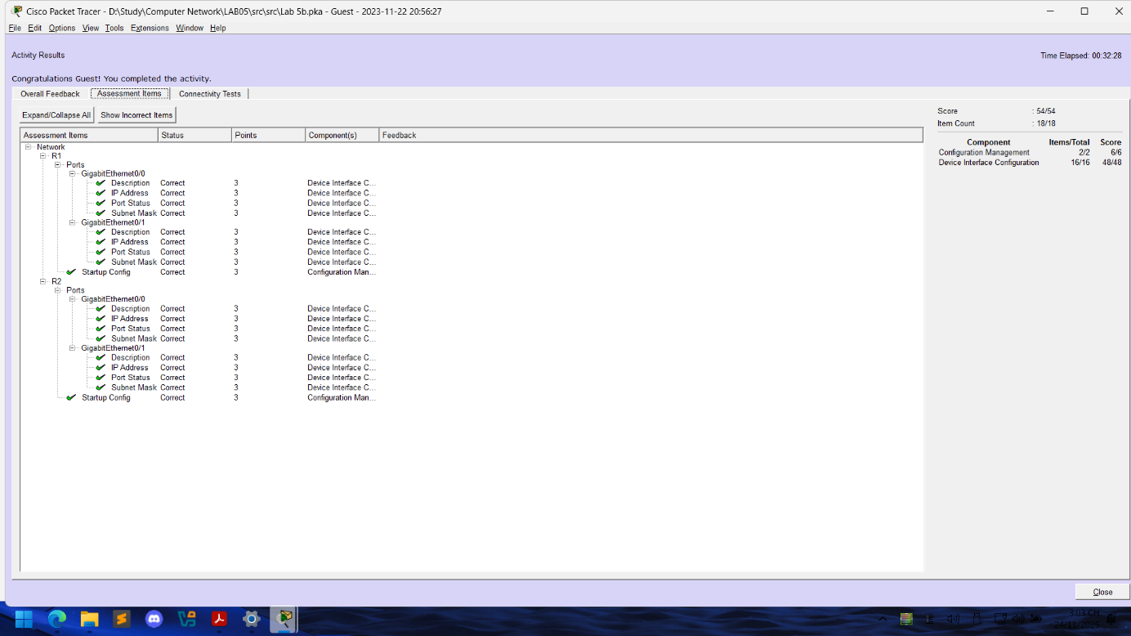

Task 3: Applying IP Address Subdivision

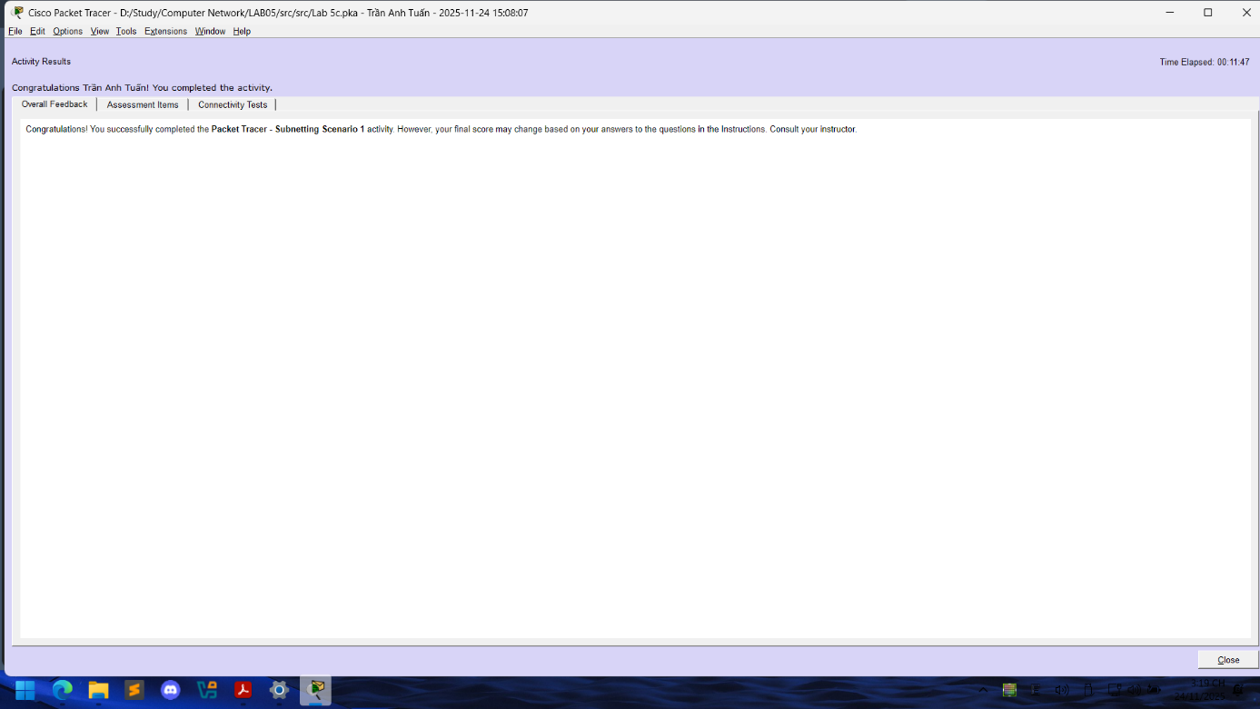
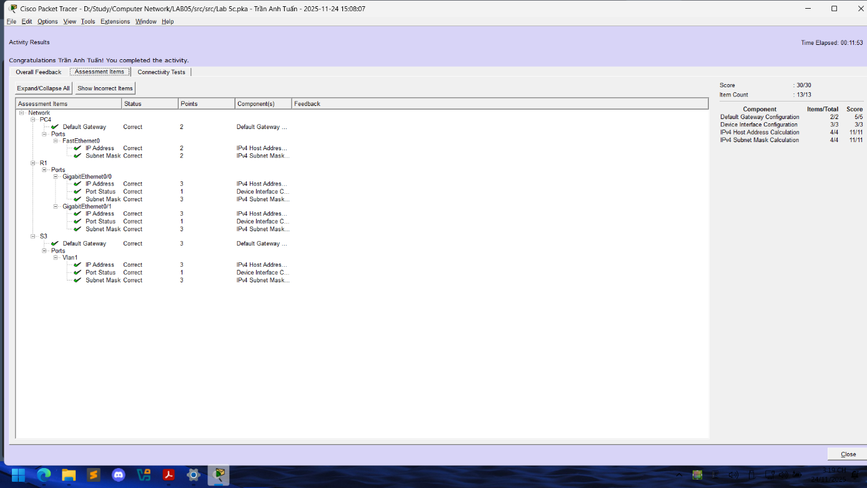

Device | Interface | IP Address | Subnet Mask | Default Gateway
R1 | G0/0 | 192.168.100.1 | 255.255.255.224 | N/A
 | G0/1 | 192.168.100.33 | 255.255.255.224 | N/A
 | S0/0/0 | 192.168.100.129 | 255.255.255.224 | N/A
R2 | G0/0 | 192.168.100.65 | 255.255.255.224 | N/A
 | G0/1 | 192.168.100.97 | 255.255.255.224 | N/A
 | S0/0/0 | 192.168.100.158 | 255.255.255.224 | N/A
S1 | VLAN 1 | 192.168.100.2 | 255.255.255.224 | 192.168.100.1
S2 | VLAN 1 | 192.168.100.34 | 255.255.255.224 | 192.168.100.33
S3 | VLAN 1 | 192.168.100.66 | 255.255.255.224 | 192.168.100.65
S4 | VLAN 1 | 192.168.100.98 | 255.255.255.224 | 192.168.100.97
PC1 | NIC | 192.168.100.30 | 255.255.255.224 | 192.168.100.1
PC2 | NIC | 192.168.100.62 | 255.255.255.224 | 192.168.100.33
PC3 | NIC | 192.168.100.94 | 255.255.255.224 | 192.168.100.65
PC4 | NIC | 192.168.100.126 | 255.255.255.224 | 192.168.100.97

END

